For the student, teacher, and staff attendance app in React, you can organize the project into several modules, sections, and tables to cover all required functionalities. Here's a detailed breakdown.

1. Modules
- Authentication Module
  - Handles login, registration, and profile management for students, teachers, and staff.
- Dashboard Module
  - Provides a centralized view for users based on their roles (student, teacher, staff).
- Attendance Module
  - Manages daily attendance records for students, teachers, and staff.
- Leave Management Module
  - Allows users to apply for leave, view leave history, and manage leave requests.
- Reports Module
  - Generates attendance and leave reports for analysis and record-keeping.
- Admin Module
  - Provides administrative controls for managing users, roles, and permissions.

2. Sections
- Login/Registration
  - User login (Students, Teachers, Staff)
  - Registration form for new users (optional if only admins create accounts)
  - Profile management
- Dashboard
  - Overview of attendance, leave requests, and notifications
  - Role-specific information display (e.g., student attendance summary, teacher attendance records)
- Attendance Management
  - Mark attendance (Students, Teachers, Staff)
  - View attendance history
  - Update or correct attendance records
- Leave Management
  - Apply for leave (Sick Leave, Holiday, Absent)
  - View leave status and history
  - Admin approval/rejection of leave requests
- Reports
  - Generate and download attendance reports
  - View monthly/weekly attendance statistics
  - Leave summary reports
- Admin Panel
  - Manage users (create, update, delete)
  - Define roles and permissions
  - Configure leave types and policies
  - Monitor system usage and performance

3. Database Tables
- Users
  - id (Primary Key)
  - name
  - email
  - password
  - role (Student, Teacher, Staff, Admin)
  - profile_picture
  - created_at
  - updated_at
- Attendance
  - id (Primary Key)
  - user_id (Foreign Key to Users table)
  - date
  - status (Present, Absent)
  - remarks (Optional notes)
  - created_at
  - updated_at
- Leave Requests
  - id (Primary Key)
  - user_id (Foreign Key to Users table)
  - leave_type (Sick Leave, Holiday, Absent)
  - start_date
  - end_date
  - status (Pending, Approved, Rejected)
  - reason
  - created_at
  - updated_at
- Roles
  - id (Primary Key)
  - role_name (Student, Teacher, Staff, Admin)
  - created_at
  - updated_at
- Permissions
  - id (Primary Key)
  - role_id (Foreign Key to Roles table)
  - permission_name
  - created_at
  - updated_at
- Leave Types
  - id (Primary Key)
  - name (Sick Leave, Holiday, Absent)
  - description
  - created_at
  - updated_at

4. Additional Considerations
- Notifications
  - You might want to include a notifications table to handle alerts for leave approvals, attendance updates, etc.
- Audit Logs
  - To track changes made by admins or users, consider an audit log table

1. Users Table
- Relationships:
  - Users have a one-to-many relationship with Attendance (one user can have multiple attendance records).
  - Users have a one-to-many relationship with Leave Requests (one user can submit multiple leave requests).
  - Users have a many-to-one relationship with Roles (each user has one role, but each role can belong to many users).

2. Roles Table
- Relationships:
  - Roles have a one-to-many relationship with Users (each role can be assigned to multiple users).
  - Roles have a one-to-many relationship with Permissions (each role can have multiple permissions).

3. Attendance Table
- Relationships:
  - Attendance has a many-to-one relationship with Users (each attendance record is linked to one user).

4. Leave Requests Table
- Relationships:
  - Leave Requests has a many-to-one relationship with Users (each leave request is submitted by one user).
  - Leave Requests has a many-to-one relationship with Leave Types (each leave request corresponds to a specific leave type).

5. Permissions Table
- Relationships:
  - Permissions have a many-to-one relationship with Roles (each permission is associated with one role).

6. Leave Types Table
- Relationships:
  - Leave Types have a one-to-many relationship with Leave Requests (each leave type can be associated with multiple leave requests).

Visual Representation
Here's how these relationships would look in an entity-relationship diagram (ERD):
- Users Table
  - One-to-Many with Attendance Table: Each user (user_id) can have multiple attendance records (user_id in the Attendance table).
  - One-to-Many with Leave Requests Table: Each user (user_id) can submit multiple leave requests (user_id in the Leave Requests table).
  - Many-to-One with Roles Table: Each user (role_id) is associated with one role (id in the Roles table).
- Roles Table
  - One-to-Many with Users Table: Each role (id) can be assigned to multiple users (role_id in the Users table).
  - One-to-Many with Permissions Table: Each role (role_id) can have multiple permissions (role_id in the Permissions table).
- Attendance Table
  - Many-to-One with Users Table: Each attendance record (user_id) is associated with one user (id in the Users table).
- Leave Requests Table
  - Many-to-One with Users Table: Each leave request (user_id) is associated with one user (id in the Users table).
  - Many-to-One with Leave Types Table: Each leave request (leave_type_id) corresponds to one leave type (id in the Leave Types table).
- Permissions Table
  - Many-to-One with Roles Table: Each permission (role_id) is associated with one role (id in the Roles table).
- Leave Types Table
  - One-to-Many with Leave Requests Table: Each leave type (id) can be associated with multiple leave requests (leave_type_id in the Leave Requests table).

Example ERD (Entity-Relationship Diagram) Structure
- Users → user_id (PK) → Attendance
- Users → user_id (PK) → Leave Requests
- Roles → role_id (PK) → Users
- Roles → role_id (PK) → Permissions
- Leave Types → leave_type_id (PK) → Leave Requests
This diagram would show the primary keys (PK) and foreign keys (FK) linking the tables, reflecting the relationships described above. The "one-to-many" relationships indicate how one record in a table (e.g., a User) can be linked to many records in another table (e.g., multiple Attendance records)

*Work Flow:
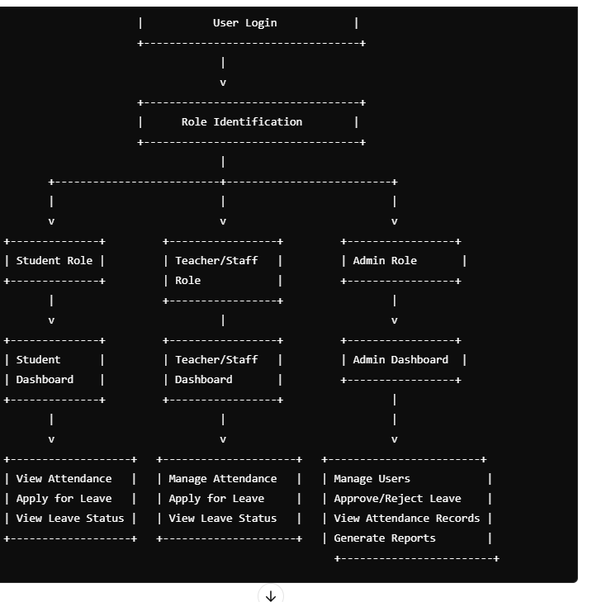

Workflow Diagram Overview
- User Authentication and Role Identification
  - User Login/Registration
  - Role Identification (Student, Teacher, Staff, Admin)
  - Dashboard Access based on Role
- Dashboard Interaction
  - Student Dashboard
    - View Attendance Summary
    - Apply for Leave
    - View Leave Status
  - Teacher/Staff Dashboard
    - View Personal Attendance
    - Manage Student Attendance (Teacher only)
    - Apply for Leave
    - View Leave Status
  - Admin Dashboard
    - Manage Users (Create/Update/Delete)
    - View All Attendance Records
    - Approve/Reject Leave Requests
    - Generate Reports
- Attendance Management
  - Mark Attendance
    - Select Date
    - Mark Present/Absent
    - Submit Attendance
  - View Attendance
    - Daily/Weekly/Monthly View
    - Attendance History
    - Export/Download Reports
- Leave Management
  - Apply for Leave
    - Select Leave Type (Sick Leave, Holiday, Absent)
    - Select Dates (Start/End)
    - Submit Reason
    - Wait for Approval
  - Admin Actions
    - Review Leave Requests
    - Approve/Reject Requests
    - Notify User of Decision
- Report Generation (Admin Only)
  - Select Parameters
    - Choose Date Range
    - Select User Group (Students/Teachers/Staff)
    - Generate Report

